**A Letter from the President: Bonnie Nelson**

Hello ACRA members,

I am honored to represent our association in the coming year. I know that 2020 has been a year of challenge for so many of you and I know we miss what was once considered “normal life”. I hope that we can soon return to that way of life very soon.

I want to thank Kelly Evers for the wonderful state meeting held last year. It was a unique situation that nobody else has ever experienced but Kelly pulled through like a CHAMP! Thank you so much, Kelly.

Over the coming year we hope to continue communicating through newsletters, Facebook group and other means of networking. With that being said, you will soon receive a list of all members. I want to provide this list to you for networking, advice or opinions. We have several new members and CTR’s and we want to help you, so please feel free to reach out to anyone on the list. If there are necessary corrections to the membership list, please contact either Jamie Williams or Wendy Culp (their contact information is on the list: as soon as possible for correcting and redistributing to members.

I want to extend my personal gratitude to this year’s board members. Many offered to stay on another year due to lack of interest in sitting on the board when nominations were requested in 2020. Your unwavering support to our organization and profession is appreciated. I implore our members to consider running for office or maybe even volunteering to help with a committee. I assure you; we are all very busy with work and personal lives, but we believe in what we do and know that we serve a greater purpose and would love to have you join us. The time spent is minimal because we work together as a board. If you are interested in helping, please reach out to me and let’s talk.

In closing, I am looking forward to this year. Be blessed and stay healthy and safe.

Best regards,

Bonnie Nelson

President of ACRA 2020-2021



*Hello members,*

*This is a time sensitive announcement and your response is required to participate. Below are links and group rate information for you to read. Your ACRA board has voted to participate in the offered group rate. In order for you to join us*

***I must have your information and money by Monday March 22, 2021.***

*Please feel free to contact me, if you have any questions.*

My mailing address is:

Bonnie Nelson

8200 Dixon Rd

Bay Minette, AL 36507

*Thank you,*

*Bonnie Nelson, ACRA President*

<https://www.ncra-usa.org/Conference/2021-Virtual-Conference>

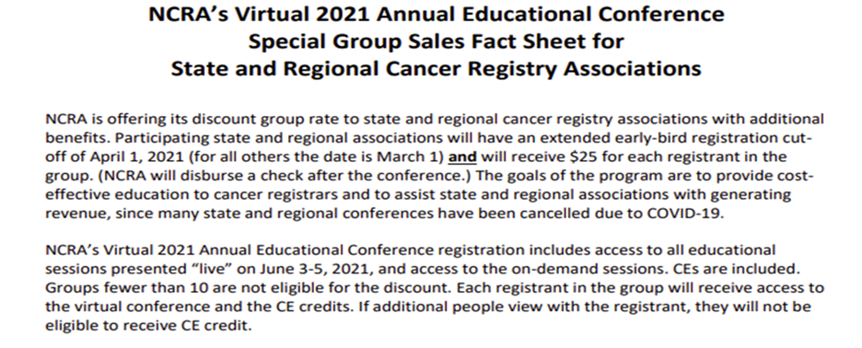

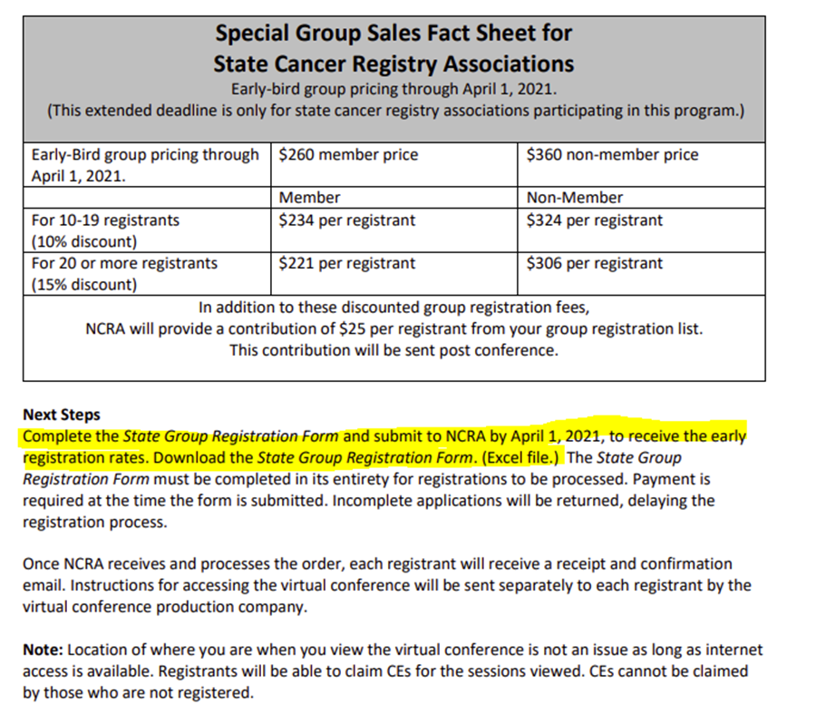

**Below is an example of what information is needed from you to enroll you. Please provide this information with your check. ALL check will be made out NCRA. NCRA WILL SEND A RECEIPT FOR YOUR RECORDS.**



**Interested in being part of the ACRA Board of Directors?**

ACRA Members,

The ACRA Board of Directors would like you to start thinking about the annual officer nominations for the 2021-2022 appointed year. Starting this month in each newsletter, we will feature an officer position and description of duties according to the bylaws. We will also add information about the current member that holds the position.

**This month we will feature the President-Elect.**

President Elect Duties: Shall assist the President in his/her duties throughout the year; shall keep informed regarding proceedings of ACRA; and, shall succeed to the office of the President at the conclusion of his/her term of office. The President-Elect shall appoint the Standing Committee Chairs for his/her term of office. The President-Elect shall appoint the Standing Committee Chairs for his/her term of office immediately after installation as President.

The current President- Elect representative is Jamie Williams CTR, MBA, MPH. Jamie has been a CTR for 7 years and she currently works for Harmony Healthcare. While serving this position Jamie is hoping to help our organization grow and is looking forward to hopefully be back to an in-person meeting soon. Jamie has also held the Historian and Treasurer officer positions.

If you have any further questions about the President-Elect position, please contact Jamie at jamallynn55@yahoo.com

ACRA elects new BOD members annually and encourage all members to consider running for positions. If you have questions concerning the positions and duties, please reach out the current officers. 

**2020-2021 ACRA Board of Directors**

|  |  |  |  |
| --- | --- | --- | --- |
| **Elected Officers** | | **Committee Chairperson and Co-Chairperson** | |
| President | Bonnie Nelson | Education/Planning | (C) Toni Terri |
| President-Elect | Jamie Williams | Bylaws | (C) Carol Kennemur |
| Immediate Past President | Kelly Evers | Membership | (C) Wendy Culp |
| Vice President | Shantel Dailey | Ways and Means | (C) Joanne Powers |
| Secretary | Jennifer Ballard | Donations | (C) Pam Tillman |
| Treasurer | Jamie Williams | Nominating | (C) Yolanda Topin |
| Treasurer-Elect | Yolanda Graham-Gaston | Ballots | (C) Karen Moulds |
| Parliamentarian/Historian | Joanne Powers | Website | (C) Shantel Dailey  (CC) Leila Edwards |
|  |  | Marketing | (C) Aretha Bracy |
|  |  | Facebook | (C) Bonnie Nelson  (CC) Jamie Williams |



**Coronavirus (COIVD-19) REMINDERS:**

**Three Important Ways to Slow the Spread** 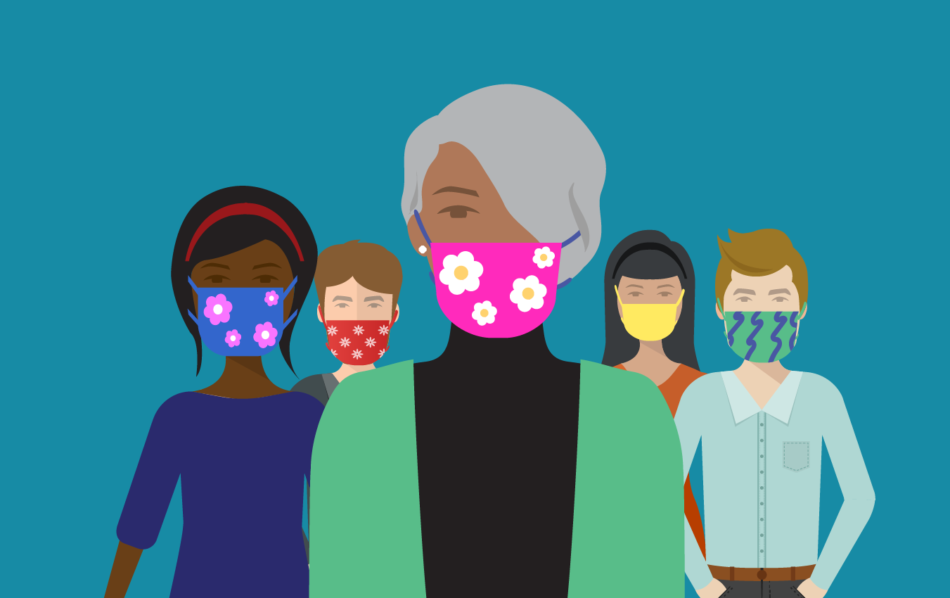

* **Wear a** [**mask**](https://www.cdc.gov/coronavirus/2019-ncov/prevent-getting-sick/diy-cloth-face-coverings.html?s_cid=aa-test-oadc-001)**to protect yourself and others and stop the spread of COVID-19.**
* Everyone 2 and older should wear masks in public.
* Masks should be worn in addition to staying at least 6 feet apart, especially around people who don’t live with you.
* If someone in your household is infected, people in the household [should take precautions including wearing masks to avoid spread to others](https://www.cdc.gov/coronavirus/2019-ncov/prevent-getting-sick/protect-your-home.html).
* [Wash your hands](https://www.cdc.gov/handwashing/when-how-handwashing.html) or use hand sanitizer before putting on your mask.
* Wear your mask over your nose and mouth and secure it under your chin.
* Fit the mask snugly against the sides of your face, slipping the loops over your ears or tying the strings behind your head.
* If you have to continually adjust your mask, it doesn’t fit properly, and you might need to find a different mask type or brand.
* Make sure you can breathe easily.
* [**Stay at least 6 feet (about 2 arm lengths)**](https://www.cdc.gov/coronavirus/2019-ncov/prevent-getting-sick/social-distancing.html) **from others who don’t live with you.**
* **Avoid crowds. The more people you are in contact with, the more likely you are to be exposed to COVID-19.**

**For more COVID-19 information, please visit: https://www.coronavirus.gov/**



**How to Cope with Stress in the midst of this pandemic:**

* [Care for yourself](https://www.cdc.gov/coronavirus/2019-ncov/daily-life-coping/managing-stress-anxiety.html) one small way each day.
* Unwind by doing yoga, listening to music, or gardening.
* Find new ways to [connect with family and friends](https://www.cdc.gov/coronavirus/2019-ncov/daily-life-coping/managing-stress-anxiety.html#everyone), get support, and share feelings.
* Eat healthy foods and get enough rest
* Relax by reading, listening to music, or starting a new hobby.



Even through the current pandemic, we are seeing cancer registry data collection changes! I have put together this chart below for easy access to updated reference materials.

|  |  |
| --- | --- |
| **Reference Manual/Material** | **Website Links** |
| SEER Registry Operations Page | <https://seer.cancer.gov/registrars/> |
| 2018 Solid Tumor Rules Updates | <https://seer.cancer.gov/tools/solidtumor/> |
| SEER Program Coding and Staging Manual 2021 | <https://seer.cancer.gov/tools/codingmanuals/> |
| Hematopoietic Project Updated 9/2020 | <https://seer.cancer.gov/tools/heme/> |
| ICD-O-3 Coding Materials- Updated | <https://seer.cancer.gov/icd-o-3/> |
| ICD-O-3 Coding Updates & Implementation Guidelines | <https://www.naaccr.org/icdo3/> |
| Version 21 Reference Page | <https://www.naaccr.org/v21referencepage/> |
| Alabama Statewide Cancer Registry Page | <https://www.alabamapublichealth.gov/ascr/index.html> |
| Extend of Disease 2018 and later | <https://staging.seer.cancer.gov/eod_public/home/2.0/> |

If you would like to add or see specific information in the next ACRA newsletter, please contact Shantel Dailey, Vice President at [chsn2@ymail.com](mailto:chsn2@ymail.com). You can always email the information directly to me to be added to the Spring (April/May) 2021 newsletter.

**STAY SAFE AND STAY POSITIVE!!**