

\***ACRA 2019-2020 Officers and Committee Chairs\***

|  |  |  |  |
| --- | --- | --- | --- |
| **Officers** | | **Committee**  **Chairperson and CoChairperson** | |
| **President** | Kelly Evers | **Education/Planning** | C- Bonnie Nelson  CC- Sonya Rhodes  Kelly Evers |
| **President Elect** | Bonnie Nelson | **Bylaws** | C- Carol Kennemur  CC- Judy Smith |
| **Immediate Past President** | Lelia Edwards | **Membership** | C- Wendy Culp  CC- Jamie Williams |
| **Vice President** | Yolanda Graham-Gatson | **Ways and Means** | C- Joanne Powers  CC- Patty Hines |
| **Secretary** | Diane Lolley | **Donations** | C- Sonya Rhodes  CC- Patty Hines |
| **Treasurer** | Jamie Williams | **Nominating** | C- Yolanda Topin  CC- Karen Moulds |
| **Treasurer-Elect** | Wendy Culp | **Ballots** | C- Bonnie Nelson  CC- Sheila Grant |
| **Historian/Parliamentarian** | Joanne Powers | **Website** | C-Shantel Dailey  CC- Lelia Edwards |
|  |  | **Marketing** | C- Patricia Caldwell-Jamieson  CC- Aretha Bracy |

**Charter Member: Lelia Edwards**

[](https://www.google.com/imgres?imgurl=https://cdn.clipart.email/74410f1d02b1dfa0cbf6e00319a96800_28-collection-of-colorful-music-notes-clipart-high-quality-_1300-641.jpeg&imgrefurl=https://www.clipart.email/clipart/music-notes-clipart-color-144071.html&tbnid=6ffxIAvS5B32GM&vet=12ahUKEwjG6rb4ne7nAhVP0VMKHceGCsEQMygcegQIARBM..i&docid=vdQVIv6I7yS4WM&w=1300&h=641&q=colors%20of%20music%20notes&hl=en-US&safe=strict&ved=2ahUKEwjG6rb4ne7nAhVP0VMKHceGCsEQMygcegQIARBM)A Note From The President

Note from the President:

     I want to say that I am honored to be your 2019-2020 ACRA President but WOW, what a year to follow. I want to take this opportunity to thank Mrs. Lelia Edwards and her fellow officers and committee for an amazing 40th year conference.

     I want to thank my elected officers, board members, committee chairs and co- chairs for their participation, input, expertise and commitment to our organization.

     We have been planning our annual conference for October 8th and 9th here at Gadsden Regional Medical Center. We have and will be reaching out to all of you for different things while we prepare for the conference.

As you know, due to the COVID crisis, we have elected to conduct a virtual meeting this year on October 1st and October 2nd 2020. It saddens us all that we will not be able to meet in person and enjoy that fellowship together. This brings on a new set of challenges but I know that our association can embrace and overcome as so many other challenges our profession encounters. Change is something we are all too aware of in this field. LOL

We are looking into various options and avenues to make the most out of this meeting. Seeing how to conduct the meeting and utilize our speakers, etc. We will be checking into education credits as well. I am unsure at this point how all of this will play out, but we will update everyone as the plans evolve.

If you have any thoughts, suggestions or concerns, please feel free to email me at

[Kelly_Evers@gadsdenregional.com](mailto:Kelly_Evers@gadsdenregional.com)

**EDUCATIONAL CORNER**



**Coding Lymph node FNA/Biopsy**

Removal, biopsy or aspiration (FNA) of a lymph node is considered a surgery.

Record all surgical procedures that remove, biopsy, or aspirate regional

lymph node(s) whether or not there were any surgical procedures of the

primary site. The regional lymph node surgical procedure(s) may be done to

diagnose cancer, stage the disease, or as a part of the initial treatment.

Example: Patient has a sentinel node biopsy of a single lymph node. Assign

code 2 (Sentinel lymph node biopsy [only]) in Scope of Regional Lymph node

Surgery.

Use date of lymph node biopsy in surgery date as treatment.

*https://seer.cancer.gov/manuals/2018/SPCSM_2018_maindoc.pdf

|  |
| --- |
| **CODING TIPS** |
|  |
| **Surgery of Primary Site**   * SEER Coding Manual’s Appendix C: Site Specific Coding Modules is a good resource for coding surgery of the primary site. The surgery codes are based on the STORE Manual and contain additional information and instructions. Here are some common coding errors. |
|  |
| **Cystoprostatectomy**   * Cystoprostatectomy is surgery to remove the urinary bladder and the prostate (a combination cystectomy and prostatectomy). When coding this procedure, make sure you use the correct site-specific code. A cystoprostatectomy is coded different depending on whether the primary cancer site is bladder (71) or prostate (70). |
|  |
| ***Bladder***   * 70 Pelvic exenteration, NOS * 71 Radical cystectomy including anterior exenteration * For females, includes removal of bladder, uterus, ovaries, entire vaginal wall, and entire urethra. * For males, includes removal of the prostate. When a procedure is described as a pelvic exenteration for males, but the prostate is not removed, the surgery should be coded as a cystectomy (code 60-64). |
|  |
| ***Prostate***   * 70 Prostatectomy WITH resection in continuity with other organs; pelvic exenteration * Surgeries coded 70 are any prostatectomy WITH resection in continuity with any other organs. The other organs may be partially or totally removed. Procedures may include, but are not limited to, cystoprostatectomy, radical cystectomy, and prostatectomy. |
|  |
| ***Breast***   * Mastectomy Coding * Make sure you read the operative notes closely when coding breast cases and you see the phrases “nipple sparing mastectomy” or “skin sparing mastectomy.” * The 2018 STORE Manual indicates that the correct code for a “nipple sparing mastectomy” is code 30 (subcutaneous mastectomy). * A “skin sparing mastectomy” is NOT the same as a “nipple sparing mastectomy.” Review the available operative reports to determine the extent of the surgery. This mastectomy can be classified as simple, total, modified radical, etc. |
|  |

ANNOUCEMENTS





|  |
| --- |
| Dear Cancer Programs Colleagues:  The leadership and staff of the American College of Surgeons Commission on Cancer (CoC), National Accreditation Program for Breast Centers (NAPBC), and the National Accreditation Program for Rectal Cancer (NAPRC) are committed to the health and safety of our participating accredited program staff, health care professionals, physicians, and patients as we continue dealing with ramifications of the COVID-19 pandemic. We would like to provide an update on our plans to begin resuming site visits and to share new resources that will become available to our participating programs later this month.  Accreditation Site Visits  In early March we made the decision to postpone 2020 accreditation site visits for 8 months and to further postpone 2021 site visits to 2022. Beginning this month, the CoC and NAPBC site reviewers will begin contacting those programs due for a site visit in 2020 to start the rescheduling process. As our site reviewers contact these programs, it is our intention that they will work to establish a mutually agreeable date for the site visit beginning this fall and extending through June 2021. We hope that by that time we will be able to complete the remaining site visits that were postponed beginning in March. Please give your site reviewer time to contact you over the next month.  Because there may continue to be concerns about traveling and holding gatherings of large groups, we have developed a virtual site visit plan that we will offer as an alternative to the in-person visit. We will pilot test the plan with a few CoC and NAPBC programs in July and August and will subsequently evaluate the results, refine the plans, train our site reviewers, and communicate this option to our programs. The NAPRC is also in the preliminary stages of investigating a virtual site visit option, and site reviewers will begin contacting postponed programs to discuss rescheduling. We feel that the virtual plans we have developed will retain the key components of the in-person visit and offer the same level of quality to assess compliance with the accreditation standards, provide education and consultation, and offer strategies to help programs enhance the quality of their cancer care delivery. More information about this option is forthcoming. In the meantime, please work with your site reviewer to re-schedule your site visit, which can always be switched to a virtual visit later.  New Resources to Support Accreditation  Later this month, we plan on releasing the following resources to support standards compliance:  **COVID-19 Accreditation Tracker** – This resource will assist programs with documenting the impact of COVID-19 on compliance with the CoC accreditation standards. Cancer programs have requested additional detail on compliance expectations for the individual standards and it is our intent that this resource will build on our previous communication regarding accommodations for disruptions to normal program operations due to the pandemic. Please note that programs will not be penalized for standards that could not be met due to the impacts of the pandemic. Similar trackers are in development to support the NAPBC and NAPRC standards.  **Cancer Program Activity Template**s – The new CoC Program Review Questionnaire (PRQ), currently in development to support the 2020 standards, is on schedule to be released this fall. This will replace the current Survey Application Record (SAR). Major components of program activity will now be tracked using templates that will be uploaded into the new PRQ. We are completing development of 11 templates for programs to use to track a variety of program activities, i.e., cancer committee meetings, cancer program goal, etc. The NAPBC is also developing some new templates and both the NAPBC and NAPRC PRQs will be released later this summer.  **Folder Structure Resource** – Because preparing for CoC accreditation is a multidisciplinary, cross-program initiative, an effective file and folder structure is essential for organizing accreditation documents. This resource will provide tips and techniques for organizing your content in an ongoing fashion to make site visit preparation easier and less burdensome. Folder structure resources to support the NAPBC and NAPRC programs will be released later in June.  **Standards Resource Library** - The new Standards Resource Library will be accessible from CoC Datalinks for access by CoC program staff and will include a variety of resources relevant to various standards to support compliance with the 2020 standards.  New Education and Training  Due to the COVID-19 pandemic, we have canceled in-person workshops on the CoC and NAPBC standards and accreditation processes. In order to fill this void, the CoC and NAPBC will each be hosting a webinar series over the next several months to support compliance with the accreditation standards. The CoC schedule was included in the most recent issue of Cancer Program News and can be found on our [website](http://www.mmsend26.com/link.cfm?r=ss5DOJLDtgeaXbjmNaGeHw~~&pe=3flMU_4Z289ssWPoW3sdImrI72omjv6baIhN00mC1zOSoqqJSVVE0W-hubx_OQYxwcdEDRizMmz_dHXKbrYFMg~~&t=INSERT_TRACKING_ENCID). These programs are free although registration is required. Later this month we will be releasing information on the NAPBC education series, which will also be free.  We look forward to your participation in these programs. We encourage you to regularly visit the following accreditation program websites for program updates and resources. We value your continued participation in our accreditation programs, and welcome your feedback, questions and concerns. Please contact us anytime at acscancerprograms@facs.org. Thank you.  [Commission on Cancer](http://www.mmsend26.com/link.cfm?r=ss5DOJLDtgeaXbjmNaGeHw~~&pe=9CkERGrNSIOsBFMzI5qMf9eN8437Bk_ix4mZ3EORYTdNfBHxzJ5-gxRo2XKmOsKaRGmdGyfZoCQkNIwFy8aI1Q~~&t=INSERT_TRACKING_ENCID)  [National Accreditation Program for Breast Centers](http://www.mmsend26.com/link.cfm?r=ss5DOJLDtgeaXbjmNaGeHw~~&pe=mtl6aj7fbEp00LTrotKt5rnpzGMfwF3lBLqyOJ6_nZeMDby1dGKTNOUzcC0BQ7MEp50558AO10H1pMuUCyi_Rg~~&t=INSERT_TRACKING_ENCID)  [National Accreditation Program for Rectal Cancer](http://www.mmsend26.com/link.cfm?r=ss5DOJLDtgeaXbjmNaGeHw~~&pe=Um3QYcNZF1XYRKszvg4zpt30_h0VUnSaJsl-39exC1XVS0rXpcCfJW_n5vZK1X_qhZ1PGcu1l-AwvnUHOa_uGg~~&t=INSERT_TRACKING_ENCID) |
|  |



The 2020 [National Cancer Database](https://urldefense.proofpoint.com/v2/url?u=http-3A__www.mmsend26.com_link.cfm-3Fr-3Dp7OyOsdmuIRoHim26e10zw-7E-7E-26pe-3DK-5FjPYCG-5FQiCw7m4vioQCfHBO8DhnGMaK5pP5Uf-2DXlZwGeoJ5ZDQL1KB3v5oPKM9Ee76-2DYOnIQBJ-2Di9rn3-2DZmZQ-7E-7E-26t-3D29IsnidirvH2revUKJVwVg-7E-7E&d=DwMFAw&c=o3PTkfaYAd6-No7SurnLt5qpge1aKYwPQyBFS7c8AA0&r=YzJOD_dNie6PPh4RbAQx_0JIh-OxGPEsugD4TSxhRaA&m=k3k8PMh8RRJNimSC-cydbgIC8yBZHjxRSx9hNDUnajg&s=Ve1L1iRdS_TEPkNbWxIA8QE-tuPtx3V2BQoCOfkbtnA&e=) (NCDB) [Call for Data](https://urldefense.proofpoint.com/v2/url?u=http-3A__www.mmsend26.com_link.cfm-3Fr-3Dp7OyOsdmuIRoHim26e10zw-7E-7E-26pe-3Dyn-5FlkPrP-5FgR-2DILLZ8ftvhSWgyaBljM6a2pzisrafaAXOvd-2DoRgvtayB2d5k5pzUNPFNGbeqMjhnq-2DrvBTPrEcQ-7E-7E-26t-3D29IsnidirvH2revUKJVwVg-7E-7E&d=DwMFAw&c=o3PTkfaYAd6-No7SurnLt5qpge1aKYwPQyBFS7c8AA0&r=YzJOD_dNie6PPh4RbAQx_0JIh-OxGPEsugD4TSxhRaA&m=k3k8PMh8RRJNimSC-cydbgIC8yBZHjxRSx9hNDUnajg&s=inGe5CWQEgznvFFLW2mAdFKbV910ET-ssieLy0Qs_qg&e=) was originally scheduled to be conducted from January 1 through May 31, 2020. We understand many hospital registrars may be experiencing work disruptions due to the COVID-19 pandemic and related adjustments being made by hospitals across the country. Due to the many issues registrars are experiencing, the **2020 Call For Data window will be extended to August 31, 2020 (11:59 pm CST) for submissions and corrections** to allow programs to successfully meet the Commission on Cancer (CoC) [Standards 5.5 and 5.6](https://urldefense.proofpoint.com/v2/url?u=http-3A__www.mmsend26.com_link.cfm-3Fr-3Dp7OyOsdmuIRoHim26e10zw-7E-7E-26pe-3D96PObwiVkaf2pfx-2DQT-5FKnuDx-5Fw-2DsbGzjwB2nBj7YOPkKYWP-2DsB13VwMYcr8-2DwbU1w6XhYlKrDzzEMnMCFwFM0g-7E-7E-26t-3D29IsnidirvH2revUKJVwVg-7E-7E&d=DwMFAw&c=o3PTkfaYAd6-No7SurnLt5qpge1aKYwPQyBFS7c8AA0&r=YzJOD_dNie6PPh4RbAQx_0JIh-OxGPEsugD4TSxhRaA&m=k3k8PMh8RRJNimSC-cydbgIC8yBZHjxRSx9hNDUnajg&s=NGGyzdSJnn5Aghi27NiNs7Jpj7UQmDvbgH6_Fe-RB6w&e=) requirements.

Our thoughts and prayers are with all registrars, hospital workers and patients during these times, and we will continue to monitor the situation as it unfolds



Please go to <https://seer.cancer.gov/tools/covid-19/index.html> to read the

COVID-19 Abstraction Guidance

**June 2020**

**Revised June 17, 2020**

Please go to <https://seer.cancer.gov/tools/solidtumor/clarifications.html> to review

**Histology Coding Clarifications- June 29, 2020**

|  |  |
| --- | --- |
| |  | | --- | | https://files.constantcontact.com/04db6536001/0583dc37-0f38-4283-ab02-0c9ce1c591bb.png | |
| |  | | --- | |  | | |  | | --- | | **Register Today!**  **NCRA's Virtual 46th Annual Educational Conference**    NCRA is excited to offer its 46th Annual Educational Conference as a virtual event, and we hope you can join us!  **Educational Sessions and Programming**  NCRA plans to offer the original educational sessions with some time adjustments to address a virtual platform. The conference sessions will be presented live September 21-23 and available on-demand as archived sessions through December 31, 2020. The conference program includes two days of plenary sessions and a third day with four, concurrent symposia. [**Review the Educational Sessions**](https://urldefense.proofpoint.com/v2/url?u=http-3A__r20.rs6.net_tn.jsp-3Ff-3D001FCpodwkJoEbGSfrUIOCr4p-2DqpsVRdUofSfHejiv8Tg5hLw3QKDk98C3qOzioTE0QEZ9yUFBA6dhYYO3rrPKHLEEy20L2FI3CWPXSzCUhpuVjd-5Fq4akXvBmye2mkmWghRzJTJdrgdKfMJXMN8hkwEUl91WbeZynt-2DUpW5jFOJbPkg0MESDzaTT3dZGOq3cjG5BkUubtC1N4PqwyYtzrGJHOnpdOHO0hROUaVdOWD5TUzYulcMo9LKtg4NMuwREmPCDUoq9ANfs6t5TgGsp-5Fxj0wwTCcTtpxWBF24pLOOznGq1DTtS9fORrRrigQs4rTs6HKFtnrDu6tM-3D-26c-3DHyuBzQBzksaMCSKnLLGYOYC2aN9KWzSdpIrkTF-2D9p-2DWYtVLvUP7SDA-3D-3D-26ch-3DlEk5fAOrPDWdwnyXM4BvK96oZrDZGw8y0-2DkBuKpNHpyNjD9pSvVX2Q-3D-3D&d=DwMF-g&c=o3PTkfaYAd6-No7SurnLt5qpge1aKYwPQyBFS7c8AA0&r=Vh4uFfdwXU1zv_CiB9Bg0mC0PQaluguTOSOTsj09gJk&m=FqePGXhZKbS9zn5lXdl6_c6JpYEcyvEdAX5Hq9hRvTQ&s=n7CGa7m1fXWO37QieJQv6IT_aOwQbCKW_D4PPIm7p5s&e=). Over 29 CEs will be available. This includes both live and on-demand sessions. A process will be available to claim CEs and to access a certificate of attendance. NCRA also plans a virtual exhibit hall, online basket raffles, roundtable discussions, and virtual networking opportunities. NCRA is also working with CDC-NPCR and NCI-SEER on next steps regarding their respective workshops. Details on the workshops will be posted soon.  **Registration Information and Pricing**  NCRA member price is $200; non-member price is $300. Registration closes September 10. There is no daily or guest registrations. [**Register online**](https://urldefense.proofpoint.com/v2/url?u=http-3A__r20.rs6.net_tn.jsp-3Ff-3D001FCpodwkJoEbGSfrUIOCr4p-2DqpsVRdUofSfHejiv8Tg5hLw3QKDk98C3qOzioTE0Q3Ujc-2DesyXO-5F5tGot3E-5F0owjdkuDMNIC7wuzK4V7AYcXa5NL0iWVxUkfBRcHXuMoo-2DeEaojZ9ewr1uh5DJ3isueVUq-5FDm5nIqbJJfAfTLWJinewn2G7TZlSMQeyF7-5F3XggcJcl7bpKOtERH6nrWf5p9fNyZ6tCwtadTXdolAszaUeXBeokjFTUM40ki1bp17tzpE-2DQNtPl7U-3D-26c-3DHyuBzQBzksaMCSKnLLGYOYC2aN9KWzSdpIrkTF-2D9p-2DWYtVLvUP7SDA-3D-3D-26ch-3DlEk5fAOrPDWdwnyXM4BvK96oZrDZGw8y0-2DkBuKpNHpyNjD9pSvVX2Q-3D-3D&d=DwMF-g&c=o3PTkfaYAd6-No7SurnLt5qpge1aKYwPQyBFS7c8AA0&r=Vh4uFfdwXU1zv_CiB9Bg0mC0PQaluguTOSOTsj09gJk&m=FqePGXhZKbS9zn5lXdl6_c6JpYEcyvEdAX5Hq9hRvTQ&s=kXn0iyK0MsFjgMWQ1T1f8AdjEvMXM-rHIEiGikk889E&e=) or use the [**registration form**](https://urldefense.proofpoint.com/v2/url?u=http-3A__r20.rs6.net_tn.jsp-3Ff-3D001FCpodwkJoEbGSfrUIOCr4p-2DqpsVRdUofSfHejiv8Tg5hLw3QKDk98C3qOzioTE0QgBTAalCiiGpI3LHc6Lehl4f8ZLvrXx7oYZnW3w1Sp15aC6lJB8OC6H7AdoHokGpCHuk-2D6lp-5F6V5-2DrCIt-5FY3rJcmNy47hh-5FAaI3B5ksTlczsb7gVRvef7QrPuV-5FgfssemJuKqqefOhPBSHq8-5FC-5FUvhssXm-5FuJ-5FSZMextySWkhs-5FhHvUS-2DsMtuSdtMiCeLN8oHIbeeRyYgYUPGY5wr7dWmckMtc2r7QB1y-2D9dXI-5Fbcnoap81uh6KTR5WFEiCrebz3F-2D8C9mEWjVxqevPRl5xIwKMe6uVSr-2Db-5FnhAiFCf2E4KHFlbz2nUbKEQ-3D-3D-26c-3DHyuBzQBzksaMCSKnLLGYOYC2aN9KWzSdpIrkTF-2D9p-2DWYtVLvUP7SDA-3D-3D-26ch-3DlEk5fAOrPDWdwnyXM4BvK96oZrDZGw8y0-2DkBuKpNHpyNjD9pSvVX2Q-3D-3D&d=DwMF-g&c=o3PTkfaYAd6-No7SurnLt5qpge1aKYwPQyBFS7c8AA0&r=Vh4uFfdwXU1zv_CiB9Bg0mC0PQaluguTOSOTsj09gJk&m=FqePGXhZKbS9zn5lXdl6_c6JpYEcyvEdAX5Hq9hRvTQ&s=fmD9uTAylUKmyFojK5XMJFuNXGMbiMIQP75Vm_j28Yc&e=). Group pricing for groups of six registrants or more is available. Read the [**Group Sales Fact Sheet**](https://urldefense.proofpoint.com/v2/url?u=http-3A__r20.rs6.net_tn.jsp-3Ff-3D001FCpodwkJoEbGSfrUIOCr4p-2DqpsVRdUofSfHejiv8Tg5hLw3QKDk98C3qOzioTE0QN5JvBCuAVsBkCW-5FR-5FEYUJwRcv9Z2LcgfbBMGneSk2UioUTh44poMSrFgqNoaaxX6vtBHR7gsAGSutVDChO13grsDodVAtp3K4aEJ3Evn5-5FwpgwOJHzWymrd0L5cj9QliModLZ8EEpsgz9NS5uRygmESYWglT2Sidvf5RPWfz6FmCLrjIyfskEhrhH0mbBR7oeA1Wfc5qwKzw0mqf2zXbAGp8D4lg4qvdksmXH1OoUnolm6sDbNIiAF9ymo0Y-2DnjjsrKIKDgaPbel5ISOo2m9oxpJdfOvmUL6mX7U7nbZOF9AXv7z6GPRHw-3D-3D-26c-3DHyuBzQBzksaMCSKnLLGYOYC2aN9KWzSdpIrkTF-2D9p-2DWYtVLvUP7SDA-3D-3D-26ch-3DlEk5fAOrPDWdwnyXM4BvK96oZrDZGw8y0-2DkBuKpNHpyNjD9pSvVX2Q-3D-3D&d=DwMF-g&c=o3PTkfaYAd6-No7SurnLt5qpge1aKYwPQyBFS7c8AA0&r=Vh4uFfdwXU1zv_CiB9Bg0mC0PQaluguTOSOTsj09gJk&m=FqePGXhZKbS9zn5lXdl6_c6JpYEcyvEdAX5Hq9hRvTQ&s=U-lkIjgZTr-GrV5g6nOBTNjAqIjrWWl1wiwz5qZAY-Q&e=) and access the [**Groups Sales Order Form.**](https://urldefense.proofpoint.com/v2/url?u=http-3A__r20.rs6.net_tn.jsp-3Ff-3D001FCpodwkJoEbGSfrUIOCr4p-2DqpsVRdUofSfHejiv8Tg5hLw3QKDk98C3qOzioTE0QxWGQqvXZwsV7J8nrWgQ7rTu9g5rcK6zoTjotSWZcM9JXerrS1d4zWAhTCwXikG2gaO-5FJa-5FkqUrKOcV5yI9kiNJs2W-2D53GreM7dP3rJ5uK0-2D-2DnAIOrIrL-5F0noSivKTez1W6xHCb6GYNwt5NF2cCC9HIdTaGj1ma5MHua8ahjhxfv-2DCR0DIG9YoKpzWmmNvAvKFppv7cqD8GGHj3NxhaI2ug-3D-3D-26c-3DHyuBzQBzksaMCSKnLLGYOYC2aN9KWzSdpIrkTF-2D9p-2DWYtVLvUP7SDA-3D-3D-26ch-3DlEk5fAOrPDWdwnyXM4BvK96oZrDZGw8y0-2DkBuKpNHpyNjD9pSvVX2Q-3D-3D&d=DwMF-g&c=o3PTkfaYAd6-No7SurnLt5qpge1aKYwPQyBFS7c8AA0&r=Vh4uFfdwXU1zv_CiB9Bg0mC0PQaluguTOSOTsj09gJk&m=FqePGXhZKbS9zn5lXdl6_c6JpYEcyvEdAX5Hq9hRvTQ&s=8nAuK06X4_BtdVcWVx_Ih8yJYyEJp1PLPCKikNansNw&e=) Questions? E-mail Nancy Allen at [**nallen@ncra-usa.org**](mailto:nallen@ncra-usa.org).  **Frequently Asked Questions**  NCRA has prepared FAQs for registrants of the in-person conference and workshops, exhibitors, and speakers. [**Read the FAQs**](https://urldefense.proofpoint.com/v2/url?u=http-3A__r20.rs6.net_tn.jsp-3Ff-3D001FCpodwkJoEbGSfrUIOCr4p-2DqpsVRdUofSfHejiv8Tg5hLw3QKDk98Jl-5F-5FyPzPeWVuWNkHWE3FEJWZxEjxVIGVP1o8xqjV71s0Sn9vdIasjobX4qK14rBzOja9dvRcLdd2rqg4ardYA-2DDMUzgrVdsUcN6ru7GgHsDWf6W-2DljPuYCKRXiWzBNSGvIl0CC32VkvP9-2DnpP1-5F-5FKLX0d1eiNBoBo-5FdhNS8JAsE-2DfO9oy7qlLPntYjxuCwuxw-3D-3D-26c-3DHyuBzQBzksaMCSKnLLGYOYC2aN9KWzSdpIrkTF-2D9p-2DWYtVLvUP7SDA-3D-3D-26ch-3DlEk5fAOrPDWdwnyXM4BvK96oZrDZGw8y0-2DkBuKpNHpyNjD9pSvVX2Q-3D-3D&d=DwMF-g&c=o3PTkfaYAd6-No7SurnLt5qpge1aKYwPQyBFS7c8AA0&r=Vh4uFfdwXU1zv_CiB9Bg0mC0PQaluguTOSOTsj09gJk&m=FqePGXhZKbS9zn5lXdl6_c6JpYEcyvEdAX5Hq9hRvTQ&s=49_Xgms3kOqFg6297a-zJ-xZPuGX0wGyLd1RuueExAs&e=).  NCRA thanks you for your ongoing support, and we look forward to seeing you virtually in September! |  |  | | --- | |  | | |

REMOTE WORKERS RESOURCES FOR COVID 19

|  |
| --- |
| NCRA has compiled a series of webinars and resources to educate cancer registrars on effective work-from-home strategies. The resources are free to members and non-members.    Visit cancer registry education. org  for more information |



**FOR YOUR HEALTH**

[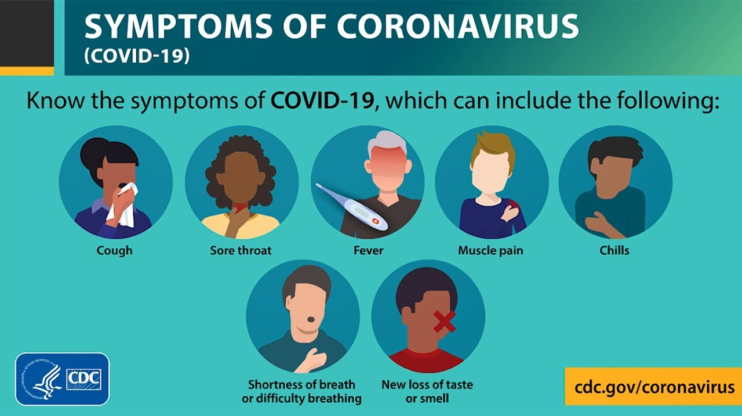](https://www.google.com/url?sa=i&url=https://www.panolawatchman.com/covid-19/symptoms-of-coronavirus-disease-2019/video_d08d9c2b-1fd8-5b7f-81e9-4ed00f3c1de7.html&psig=AOvVaw087jE9lO18FKluyWTxIiET&ust=1591150663422000&source=images&cd=vfe&ved=0CAIQjRxqGAoTCOjK7qeI4ukCFQAAAAAdAAAAABDOAQ)

**LET STOP THE SPREAD OF COVID-19**

**STAY HEALTY AND CALM**

[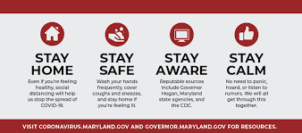](https://www.google.com/imgres?imgurl=https://bloximages.chicago2.vip.townnews.com/myeasternshoremd.com/content/tncms/assets/v3/editorial/e/0f/e0f3ee83-fc5f-5316-bb75-67d1d4a3f331/5e7a41f5f08b7.image.png?resize%3D1000,442&imgrefurl=https://www.myeasternshoremd.com/dorchester_star/community/news/testing-taking-place-dorchester-remains-at-zero-confirmed-covid-19-cases/article_417923a7-6144-5533-969e-6890f105baf0.html&tbnid=23G7ToWdJtfCdM&vet=12ahUKEwi7mu-b8NrpAhUWRFMKHdJmDUAQMygUegQIARAW..i&docid=EL2BJ3gZ6q0CLM&w=1000&h=442&q=STAY%20HEALTHY%20AND%20CALM%20DURING%20COVID%2019&safe=strict&ved=2ahUKEwi7mu-b8NrpAhUWRFMKHdJmDUAQMygUegQIARAW)

**WASH YOUR HANDS**

[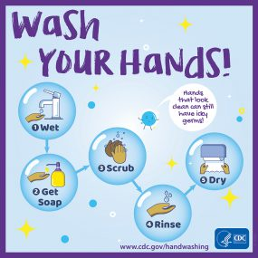](https://www.google.com/url?sa=i&url=https://www.cdc.gov/handwashing/buttons.html&psig=AOvVaw3OAvOC2nMVjKqjCGqE6qRg&ust=1590904136678000&source=images&cd=vfe&ved=0CAIQjRxqFwoTCKj69IHy2ukCFQAAAAAdAAAAABAD)

KEEP YOUR DISTANCE

[](https://www.google.com/imgres?imgurl=http://pic.zhishifenzi.com/9/pc/zsfz1588903961.52164.png&imgrefurl=http://www.zhishifenzi.com/news/biology/8958.html&tbnid=Fgu1oVu-2PQh4M&vet=10CAkQxiAoAWoXChMIqPr0gfLa6QIVAAAAAB0AAAAAEA0..i&docid=VK9NM_4ifJKaLM&w=577&h=412&itg=1&q=cdc%20keep%20calm%20and%20wash%20your%20hands&safe=strict&ved=0CAkQxiAoAWoXChMIqPr0gfLa6QIVAAAAAB0AAAAAEA0) [](https://www.google.com/imgres?imgurl=https://www.bentees.com/wp-content/uploads/2020/03/redirect-1070.jpg&imgrefurl=https://www.bentees.com/product/keep-your-distance-but-keep-smiling-shirt-hoodie-tank/&tbnid=Jd7EvNe8shuFxM&vet=12ahUKEwiH2bOh7eDpAhVGFFMKHUmdDCAQMygxegUIARCAAQ..i&docid=WKjLqgsdiN0RwM&w=1155&h=1155&q=keep%20your%20distance%20funny%20pictures&safe=strict&ved=2ahUKEwiH2bOh7eDpAhVGFFMKHUmdDCAQMygxegUIARCAAQ)

[](https://www.google.com/imgres?imgurl=https://res.cloudinary.com/teepublic/image/private/s--PqVoWH85--/t_Resized%20Artwork/c_fit,g_north_west,h_954,w_954/co_000000,e_outline:48/co_000000,e_outline:inner_fill:48/co_ffffff,e_outline:48/co_ffffff,e_outline:inner_fill:48/co_bbbbbb,e_outline:3:1000/c_mpad,g_center,h_1260,w_1260/b_rgb:eeeeee/c_limit,f_jpg,h_630,q_90,w_630/v1587519005/production/designs/9345241_0.jpg&imgrefurl=https://www.teepublic.com/sticker/9345241-social-distancing-funny-keep-your-distance-gift&tbnid=TPc1XxoZgjLggM&vet=12ahUKEwiH2bOh7eDpAhVGFFMKHUmdDCAQMygVegQIARAt..i&docid=M-z1AXvxmKEkvM&w=630&h=630&q=keep%20your%20distance%20funny%20pictures&safe=strict&ved=2ahUKEwiH2bOh7eDpAhVGFFMKHUmdDCAQMygVegQIARAt)[](https://www.google.com/imgres?imgurl=https://res.cloudinary.com/teepublic/image/private/s--24w9smxQ--/t_Resized%20Artwork/c_fit,g_north_west,h_954,w_954/co_000000,e_outline:48/co_000000,e_outline:inner_fill:48/co_ffffff,e_outline:48/co_ffffff,e_outline:inner_fill:48/co_bbbbbb,e_outline:3:1000/c_mpad,g_center,h_1260,w_1260/b_rgb:eeeeee/c_limit,f_jpg,h_630,q_90,w_630/v1587514678/production/designs/9344320_0.jpg&imgrefurl=https://www.teepublic.com/sticker/9344320-social-distancing-keep-your-distance-gifts&tbnid=-jI3AWbDfAPW8M&vet=10CCMQMyhxahcKEwiYqObq7eDpAhUAAAAAHQAAAAAQAg..i&docid=0DQwGWlxsX85IM&w=630&h=630&itg=1&q=keep%20your%20distance%20funny%20pictures&safe=strict&ved=0CCMQMyhxahcKEwiYqObq7eDpAhUAAAAAHQAAAAAQAg)

**WEAR A MASK IN PUBLIC**

[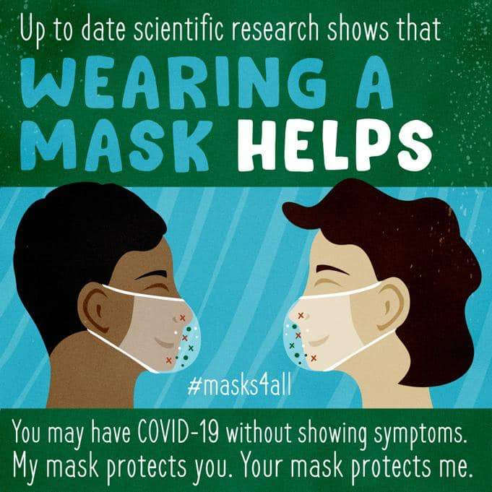](https://www.google.com/url?sa=i&url=https://skapaleather.com/collections/modern/products/mask-extender-ear-relief-band&psig=AOvVaw0lJVJHlGG6aGvZoe3pyjdY&ust=1591149860312000&source=images&cd=vfe&ved=0CAIQjRxqFwoTCKDF46mF4ukCFQAAAAAdAAAAABAn)

REMEMBER

[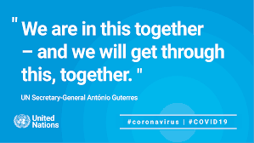](https://www.google.com/imgres?imgurl=https://www.unodc.org/images/middleeastandnorthafrica//2020/COVID-19/quote_card_rectangle_option_2.png&imgrefurl=https://www.unodc.org/middleeastandnorthafrica/en/web-stories/coronavirus-disease-covid-19---unodc-romena-updates.html&tbnid=5Z-1ZTSgEKR1_M&vet=10CAcQxiAoBGoXChMIuPWA9u7g6QIVAAAAAB0AAAAAEBI..i&docid=6EwxFJo4f7w93M&w=2501&h=1407&itg=1&q=WORDS%20OF%20ENCOURAGEMENT%20DURING%20COVID%2019&safe=strict&ved=0CAcQxiAoBGoXChMIuPWA9u7g6QIVAAAAAB0AAAAAEBI)[](https://www.google.com/imgres?imgurl=https://s3.us-east-2.amazonaws.com/inspire-kindness/posts/March2020/70b20da9-3147-45b4-9855-9875f0128ca8.jpg&imgrefurl=https://inspirekindness.com/blog/practicing-kindness-during-the-coronavirus&tbnid=K4MwlbXEJf2KLM&vet=12ahUKEwix3ajq9eDpAhUDK1MKHc7DBQ8QMygbegQIARAk..i&docid=-2FyQ6ML2_Pw2M&w=800&h=800&q=quotes%20of%20encouragement%20for%20covid%2019&safe=strict&ved=2ahUKEwix3ajq9eDpAhUDK1MKHc7DBQ8QMygbegQIARAk)

[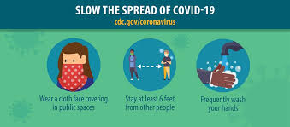](https://www.google.com/url?sa=i&url=https://www.facebook.com/CDC/posts&psig=AOvVaw0lJVJHlGG6aGvZoe3pyjdY&ust=1591149860312000&source=images&cd=vfe&ved=0CAIQjRxqFwoTCKDF46mF4ukCFQAAAAAdAAAAABAJ)