.

 |  | ACRA Spring 2021 Newsletter | May 2021
 |  | The latest news, views, and announcements
ACRA 42ND ANNUAL EDUCATIONAL CONFERENCE
ANNOUCEMENT!!!
Wednesday, Sept. 29, 2021
We are happy to provide a FREE ONE-day virtual meeting for all paid ACRA members. This meeting is scheduled to begin at 7:30 am CST and will conclude with a business meeting. We will charge $30.00 for anyone who wishes to participate but is not a member of the association. Please feel free to share this information when it is emailed to you in the coming months.

The Review
Interested in being part of the ACRA Board of Directors?  ACRA Members,  The ACRA Board of Directors would like you to start thinking about the annual officer nominations for the 2021-2022 appointed year. For every newsletter, we will highlight a specific position and add information about the current member that holds the position.  This Month’s Featured Board Officer: Secretary  Duties  Secretary shall keep a permanent record of all meeting of ACRA and shall present them at the following meeting, shall carry an official correspondence of the organization under the direction of the President, shall provide annual maintenance and oversight of the ACRA electronic library including collecting and tracking of the ACRA thumb drives from outgoing board members and re-distributing them to incoming board members after copying and/or archiving data from the past year to a CD or laptop. |  |  | Words from Current Secretary  - By Jennifer Ballard, BA, CTR  This is my second term as Secretary for ACRA. I really enjoy doing my part on the board with ACRA. When the board meets monthly, I take notes and submit them to the President for approval. It is not complicated at all. It also keeps me in the loop as far as planning for the Annual Education Conference. Being part of the board allows networking with other CTRs outside of my work environment.  I have served as Parliamentarian Historian for several terms with ACRA. I enjoyed keeping track of the happenings throughout the years that I had served. I really hadn't had to invoke the Roberts Rules of Order during the business meetings. But it is important to know them. I would highly recommend getting involved with the ACRA board in one role or another. Getting involved with committees can be fun, especially when you see your part of the Annual Meeting come together. I have been a CTR since 2004, currently work for Registry Partners, Inc.
VACCINES, VACCINES??? | About the Three COVID-19 Vaccines  “Words can save lives. Our ability to boost confidence in COVID-19 vaccines will depend largely on the language, the messengers, and methods we use to communicate to Americans that the vaccine will help keep them and their families safe and healthy.” -Dr. Brian C. Castrucci, President and CEO, de Beaumont Foundation  There are three COVID-19 vaccines available and this has presented many questions about the differences. Please see chart below, hope this answers some questions and concerns.

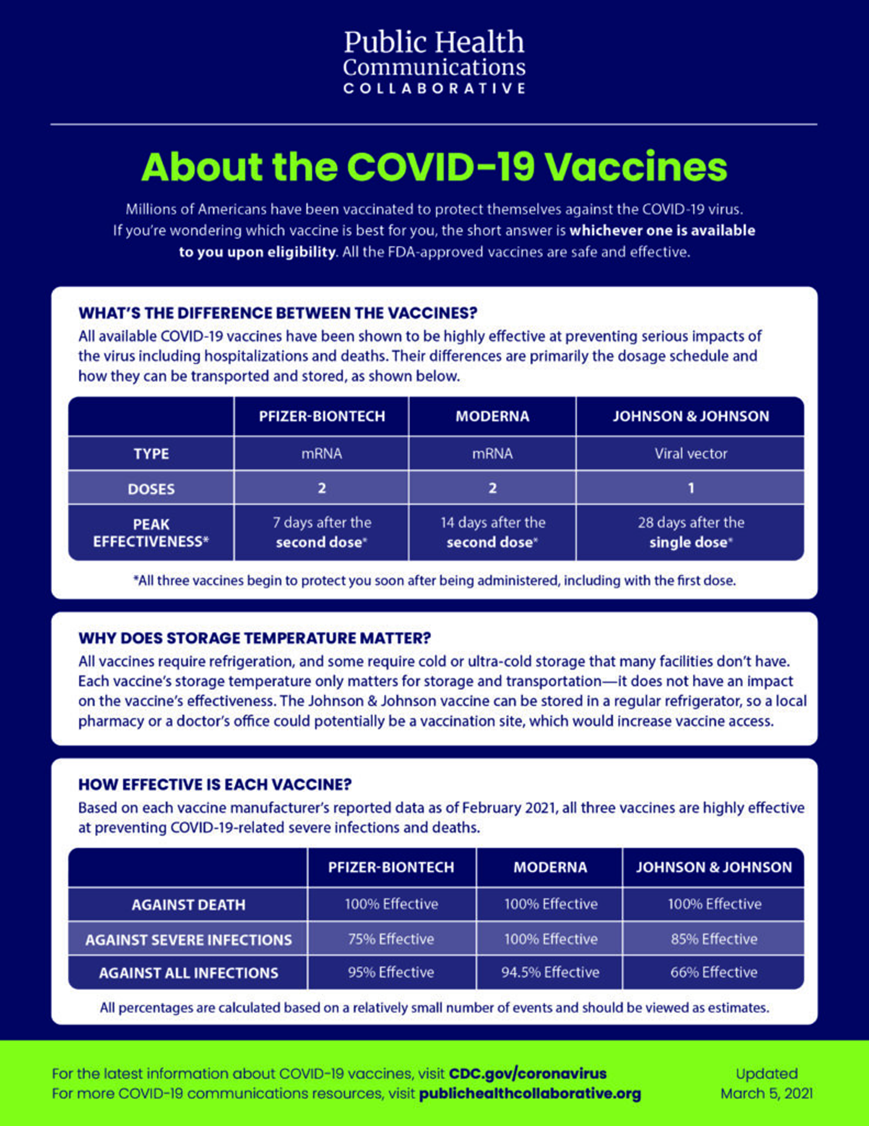

NCRA Hosts NPCR Success Stories and Quizzes on its Center for Cancer Registry Education-NOW LIVE**
http://www.CancerRegistryEducation.org/NPCR.​
Earn Four Complimentary Continuing Education (CE) Credits
CDC-NPCR’s annual Success Stories highlight compelling examples of how cancer registry data are used to improve public health. Presented as posters, these stories showcase the innovative ways central cancer registries from across the country use cancer data to help fight cancer.
Working with NPCR, the National Cancer Registrars Association (NCRA) has developed a new product on its Center for Cancer Registry Education to display these posters and offer free CEs. The posters have been organized into four topic areas – Collaboration, Data and Reporting, Public Health Impact, and Registry Management – and a quiz has been developed for each topic. Successful completion of each quiz will earn registrars a complimentary CE, for a total of four. To learn more and access the product, go to www.CancerRegistryEducation.org/NPCR.​

